Item Fit Statistics in Common Software for Rasch Analysis

- Introduction
The Rasch model for dichotomous items (Rasch, 1960) assumes that the response of a person to an item is stochastically independent of all other item responses for the same and other persons, and that the probability of a positive response to an item is equal to
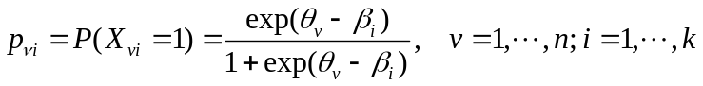, (1)
where θ_{v} is a parameter characterizing the person and β_{ι} is an item parameter.
Two different types of residuals are calculated during tests of fit of items to the Rasch model. We refer to the residual types as respectively response residuals and group residuals. Response residuals compare observed and expected for every combination of person and item. These residuals are given by
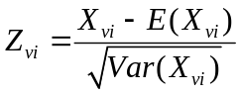, (2)
with 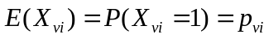 and 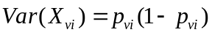. Software like Winsteps (Linacre, 2014), the R package eRm (Mair et al., 2014), and DIGRAM (Kreiner & Nielsen, 2013) calculate so-called outfits summarizing standardized response residuals,
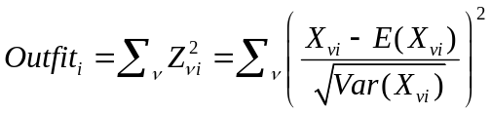. (3)
Group residuals compare the total number of positive responses to an item in a group of persons to the expected number of responses in the same group by
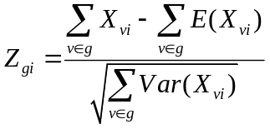. (4)
RUMM2030 (Andrich et al., 2010) uses group residuals to calculate item chi-square fit statistics as the sum of squared group residuals, where persons are grouped into classes g depending on the person's scores.
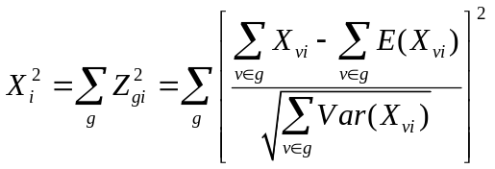 (5)
The total “item-trait interaction” chi-square test statistic is the sum of the item chi-squares.
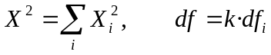 (6)
RUMM2030 assumes first, that the test statistic defined in (5) is χ² distributed with degrees of freedom 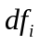 equal to the number of classes minus 1 and second, that the total “item-trait interaction” is χ² distributed with 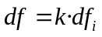 degrees of freedom. This test should show whether the data fit to the Rasch model for the classes along the scale.
The formulas for the chi-square statistics involve 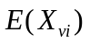 and 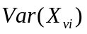, which are unknown and have to be estimated. The usual way to estimate is to plug in the item and person parameter estimates.
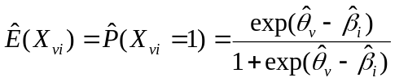 (7)
We refer to the test statistics based on residuals defined by (7) as unconditional fit statistics. The use of the unconditional residuals defined by (7) would be defensible, if the estimates of person and item parameters had been consistent. Unfortunately, in standard applications of Rasch models where the number of items is a limited fixed number the estimate of the person parameter cannot be regarded as consistent because the errors and the biases of the estimates do not disappear as the sample of persons increase.
Kreiner & Christensen (2011) raised this issue. They noticed that estimates of item and person parameters are functions of the sufficient item and person scores and that the expected outcome on the response to an item by a person should be regarded as the expected outcome conditionally given the estimates of the parameters. Because of the one-to-one relationship between the estimates of the parameters on one hand and the person and item scores on the other, they claimed that the proper estimate of the expected outcome should be the expected outcome given the sufficient person and item scores. Kreiner & Christensen (2011) show how these conditional probabilities can be calculated. They also show that these probabilities are not equal to the probabilities in (7), that the use of (7) in residuals and outfit statistics result in bias, and that the use of the conditional probabilities given the sufficient scores eliminates the bias.
Calculation of conditional probabilities is computer intensive and therefore not practical in most applications. Kreiner & Christensen (2011) point out that the estimates of the item parameters are consistent and therefore suggest that conditional probabilities given person and item scores may be very close to the conditional probabilities given the person scores where the item parameter estimates are treated as known parameters. This leads to
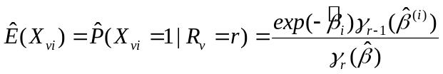, (8)
where denotes the vector of item parameters, 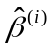 denotes the vector of item parameters without , and 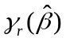 is the elementary symmetrical function of order r of the item parameter estimates. The conditional fit statistics studied in this paper use residuals which are based on (8). Full details of the calculations and related problems can be found in Christensen & Kreiner (2012).
The results of Kreiner & Christensen (2011) only relate to response residuals and outfits. The degree to which their results generalize to fit statistics based on group residuals is an open question. It is the purpose of this paper to address these questions by comparison of unconditional and conditional chi-square test statistics defined by (5) and (6).

- Methods
Data sets were simulated to fit the Rasch model, with sample sizes between 150 and 2000 and 10, 15 or 20 items. Person parameters came from a standard normal distribution. Item parameters were also chosen from a normal distribution or equidistantly fixed, ranging from -2 to +2 or from -2.5 to +2.5. Item parameters were estimated with conditional maximum likelihood, for the person parameters weighted maximum likelihood was used. Unconditional and conditional chi-square fit statistics were calculated. The distributions of the p values are then looked at and proportions of p values below 0.05, the type I error rates, were compared.
Parametric bootstrap was used to study the distributions of the chi-square test statistics for various n and k. First, a data set was generated from a Rasch model. Item and person parameters were estimated for this data set and the chi-square test statistic and p value were calculated. Next, bootstrap samples were generated from a Rasch model with parameters equal to the estimates calculated in the first step. The chi-square test statistics for the samples were used to get the empirical distribution of the test statistic. This is called the bootstrap distribution. The critical value from this distribution gives the bootstrap p value, which was compared with the p value based on the chi-square distribution. All simulations and calculations were done with the R statistical package Version 3.1.0 (R Development Core Team 2014) and the additional R packages eRm (Mair et al., 2014) and PP (Reif, 2014).

- Results
We start with simulations with normally distributed person and item parameters. Sample sizes vary between 150 and 2000, the number of items is 10, 15 or 20. The number of classes is three for n ≤ 250, and seven for larger n. For each situation 1000 simulations are done. As the Rasch model is true for all the data sets, the proportions of p values below 0.05 should be about 0.05. Table 1 shows the proportions of p values below 0.05 for unconditional and conditional individual item and total tests. Looking first at the unconditional tests, there are too many significant results regarding the total test for n ≥ 200, especially if there are not many items. For n=500 or more, the type I error rate is also increased for single item tests. Everything is okay with the conditional tests, they maintain the significance level.

[Include Table 1 here]
The percentage of p values below 0.05 is only slightly increased for unconditional tests for single items, if n=500 and k=10. However, the distribution of the p values does not look uniform anymore and is clearly skewed for the unconditional total test. In the case of conditional tests, the distributions look uniform over the interval (0,1) as they should. (see Figure 1a and 1b).

[Include Figure 1a and 1b here]

Simulations with fixed item parameters, equidistant in the interval [-2, +2] or [-2.5, +2.5], lead to very similar results. Table 2 shows the percentages of p values below 0.05 for items fixed between -2 and +2. There is some variability in the results of unconditional item tests. Higher proportions can be found for items with difficulty parameters close to 0.

[Include Table 2 here]

The results of the parametric bootstrap with n=1000, k=10 and fixed item parameters in the interval [-2, +2] agree with the results before. Table 3 contains unconditional and conditional chi-square fit statistics, and p values based on the chi-square distribution and based on the bootstrapping procedure. The two unconditional item fit statistics for item 5 and item 6 show misfit and the total test also rejects the Rasch model if the chi-square distribution is used. The bootstrap p values are larger and do not indicate any misfit. As for the conditional tests, the chi-square distribution and bootstrap p values are quite similar.
[Include Table 3 here]

Results are similar for n=1500 or n=2000 and k=10. For n=2000 and k=20 the behaviour of the unconditional item tests is improved, the difference between chi-square distribution and bootstrap p values decreases as can be seen in table 4.

[Include Table 4 here]

Figure 2 shows the bootstrap distributions for the unconditional and the conditional total test. The curve displays the proposed chi-square distribution, the dotted vertical line shows the observed chi-square test statistic for the data set generated in step 1. The solid vertical line is the critical value (p value) from the bootstrapping distribution.

[Include Figure 2 here]

- Discussion
We have looked at two different estimates of residuals, one based on inconsistent person parameters, the other based on scores. The chi-square fit statistics which use the person parameter estimates show increased Type I error rates as soon as the sample size is 200. The chi-square tests which are based on scores remain valid for n up to 2000. The parametric bootstrap confirms these results. In the case of unconditional tests, chi-square p values are much smaller than bootstrap p values, whereas chi-square distribution and bootstrap distribution quite agree for conditional tests.
Large fit statistics are therefore not just a matter of large sample sizes, problems start with n as small as 200. For a sample size of 200 or more, the unconditional total item-trait interaction chi-square test is not reliable and the statistic should not be compared with the chi-square distribution. Instead parametric bootstrapping should be used to assess the significance of the fit statistics. Unconditional item fit statistics become unreliable for n ≥ 500 and again bootstrapping is recommended. Conditional fit statistics remain reliable, at least for n≤ 2000, and bootstrapping is not necessary because the chi-square distribution can be used as an approximation.

Conflict of interest
The authors declare that there is no conflict of interest.

References
Andrich D., Sheridan B., Luo G. (2010) RUMM 2030. Rasch unidimensional measurement models software. Perth, WA, Australia: RUMM Laboratory.
Christensen,K.B, & Kreiner,S. (2012). Item Fit Statistics. In K. B. Christensen, S. Kreiner & M. Mesbah (Eds.), Rasch Models in Health (pp. 83-104). Wiley - ISTE
Kreiner,S., & Christensen,K.B. (2011). Exact evaluation of bias in Rasch model residuals. In A.R. Baswell (Eds.), Advances in Mathematics Research, Vol. 12 (pp. 19-40). Nova Science Publishers, Inc.
Linacre, J.M. (2014). Winsteps® Rasch measurement computer program. Beaverton, Oregon: Winsteps.com.
Mair, P., Hatzinger, R., & Maier M.J. (2014). eRm: Extended Rasch Modeling. R package version 0.15-4. http://erm.r-forge.r-project.org/
R Development Core Team (2014) R: A Language and Environment for Statistical Computing. R Foundation for Statistical Computing, Vienna, Austria. http://www.R-project.org.
Rasch G. (1960) Probabilistic models for some intelligence and attainment tests. Chicago: University of Chicago Press.
Reif, M. (2014). PP: Estimation of person parameters for the 1,2,3,4-PL model and the GPCM. R package version 0.5.3. https://github.com/manuelreif/PP

Table 1: Proportions of p values < 0.05 for simulations with normally distributed item parameters
n | k | Unconditional |  | Conditional
 |  | Item tests | Total test | Item tests | Total test
150 | 10 | 0.046-0.067 | 0.076 | 0.037-0.048 | 0.058
 | 15 | 0.033-0.053 | 0.064 | 0.038-0.055 | 0.059
 | 20 | 0.031-0.060 | 0.057 | 0.034-0.066 | 0.065
200 | 10 | 0.045-0.076 | 0.091 | 0.035-0.066 | 0.051
 | 15 | 0.040-0.059 | 0.061 | 0.040-0.061 | 0.051
 | 20 | 0.029-0.059 | 0.056 | 0.033-0.076 | 0.056
250 | 10 | 0.062-0.086 | 0.144 | 0.037-0.056 | 0.066
 | 15 | 0.040-0.069 | 0.070 | 0.032-0.058 | 0.049
 | 20 | 0.039-0.054 | 0.053 | 0.040-0.065 | 0.042
500 | 10 | 0.058-0.089 | 0.181 | 0.044--0.057 | 0.050
 | 15 | 0.046-0.060 | 0.086 | 0.028-0.059 | 0.055
 | 20 | 0.035-0.060 | 0.061 | 0.037-0.061 | 0.054
1000 | 10 | 0.140-0.185 | 0.729 | 0.038-0.056 | 0.056
 | 15 | 0.073-0.112 | 0.309 | 0.042-0.066 | 0.066
 | 20 | 0.048-0.081 | 0.145 | 0.041-0.065 | 0.051
1500 | 10 | 0.245-0.280 | 0.990 | 0.045-0.060 | 0.062
 | 15 | 0.092-0.131 | 0.597 | 0.042-0.063 | 0.059
 | 20 | 0.069--0.092 | 0.304 | 0.042-0.059 | 0.057
2000 | 10 | 0.370-0.405 | 1.000 | 0.055-0.077 | 0.072
 | 15 | 0.127-0.182 | 0.875 | 0.035-0.073 | 0.059
 | 20 | 0.072-0.126 | 0.473 | 0.037-0.063 | 0.055

Table 2: Proportions of p values < 0.05 for simulations with fixed item parameters in [-2, +2]
n | k | Unconditional |  | Conditional
 |  | Item tests | Total test | Item tests | Total test
150 | 10 | 0.035-0.087 | 0.074 | 0.043-0.053 | 0.058
 | 15 | 0.030-0.065 | 0.057 | 0.032-0.061 | 0.058
 | 20 | 0.032-0.060 | 0.051 | 0.036-0.056 | 0.062
200 | 10 | 0.031-0.092 | 0.107 | 0.043-0.050 | 0.050
 | 15 | 0.027-0.062 | 0.065 | 0.040-0.061 | 0.055
 | 20 | 0.030-0.063 | 0.053 | 0.036-0.068 | 0.059
250 | 10 | 0.031-0.099 | 0.153 | 0.036-0.051 | 0.047
 | 15 | 0.029-0.059 | 0.067 | 0.034-0.056 | 0.046
 | 20 | 0.031-0.061 | 0.064 | 0.039-0.062 | 0.062
500 | 10 | 0.047-0.119 | 0.228 | 0.043-0.064 | 0.059
 | 15 | 0.036-0.077 | 0.087 | 0.042-0.062 | 0.051
 | 20 | 0.036-0.059 | 0.055 | 0.036-0.062 | 0.050
1000 | 10 | 0.104-0.252 | 0.880 | 0.044-0.060 | 0.064
 | 15 | 0.047-0.110 | 0.305 | 0.036-0.059 | 0.057
 | 20 | 0.041-0.093 | 0.156 | 0.040-0.069 | 0.052
1500 | 10 | 0.190-0.416 | 1.000 | 0.036-0.057 | 0.053
 | 15 | 0.061-0.156 | 0.613 | 0.043-0.061 | 0.052
 | 20 | 0.048-0.112 | 0.304 | 0.037-0.067 | 0.048
2000 | 10 | 0.335-0.592 | 1.000 | 0.040-0.065 | 0.058
 | 15 | 0.083-0.226 | 0.907 | 0.036-0.060 | 0.058
 | 20 | 0.055-0.130 | 0.505 | 0.034-0.057 | 0.054

Table 3: Bootstrapping with n=1000 and k=10
 | Unconditional |  |  | Conditional
 | Chi-square statistic | P value Chi-square | P value Bootstrap | Chi-square statistic | P value Chi-square | P value Bootstrap
Item 1 | 4.642 | 0.591 | 0.891 | 1.627 | 0.951 | 0.953
Item 2 | 4.793 | 0.571 | 0.863 | 2.302 | 0.890 | 0.896
Item 3 | 5.471 | 0.485 | 0.816 | 2.416 | 0.878 | 0.873
Item 4 | 5.754 | 0.451 | 0.789 | 4.861 | 0.562 | 0.528
Item 5 | 13.752 | 0.033 | 0.181 | 4.422 | 0.620 | 0.612
Item 6 | 14.734 | 0.022 | 0.154 | 6.483 | 0.371 | 0.348
Item 7 | 7.290 | 0.295 | 0.674 | 11.559 | 0.073 | 0.073
Item 8 | 10.436 | 0.107 | 0.347 | 4.641 | 0.591 | 0.578
Item 9 | 9.568 | 0.144 | 0.346 | 7.659 | 0.264 | 0.256
Item 10 | 6.391 | 0.381 | 0.633 | 3.100 | 0.796 | 0.785
Total | 82.830 | 0.027 | 0.770 | 49.070 | 0.842 | 0.815

Table 4: Bootstrapping with n=2000 and k=20
 | Unconditional |  |  | Conditional
 | Chi-square statistic | P value Chi-square | P value Bootstrap | Chi-square statistic | P value Chi-square | P value Bootstrap
Item 1 | 3.892 | 0.691 | 0.842 | 2.942 | 0.816 | 0.819
Item 2 | 8.109 | 0.230 | 0.331 | 10.543 | 0.104 | 0.094
Item 3 | 5.827 | 0.443 | 0.579 | 3.197 | 0.784 | 0.772
Item 4 | 3.402 | 0.757 | 0.882 | 2.751 | 0.839 | 0.849
Item 5 | 8.317 | 0.216 | 0.351 | 3.729 | 0.713 | 0.716
Item 6 | 5.955 | 0.428 | 0.571 | 3.094 | 0.797 | 0.781
Item 7 | 5.425 | 0.491 | 0.669 | 3.721 | 0.714 | 0.712
Item 8 | 3.807 | 0.703 | 0.833 | 2.041 | 0.916 | 0.914
Item 9 | 8.430 | 0.208 | 0.379 | 5.933 | 0.431 | 0.420
Item 10 | 10.640 | 0.100 | 0.210 | 8.249 | 0.220 | 0.226
Item 11 | 6.685 | 0.351 | 0.548 | 9.159 | 0.165 | 0.164
Item 12 | 1.895 | 0.929 | 0.968 | 1.438 | 0.964 | 0.954
Item 13 | 14.045 | 0.029 | 0.080 | 10.609 | 0.101 | 0.095
Item 14 | 9.842 | 0.131 | 0.266 | 11.925 | 0.064 | 0.059
Item 15 | 5.655 | 0.463 | 0.623 | 3.957 | 0.682 | 0.689
Item 16 | 3.763 | 0.709 | 0.842 | 2.212 | 0.899 | 0.894
Item 17 | 10.648 | 0.100 | 0.140 | 5.708 | 0.457 | 0.445
Item 18 | 11.279 | 0.080 | 0.139 | 8.282 | 0.218 | 0.227
Item 19 | 5.166 | 0.523 | 0.672 | 7.413 | 0.284 | 0.270
Item 20 | 8.387 | 0.211 | 0.284 | 7.824 | 0.251 | 0.244
Total | 141.168 | 0.091 | 0.681 | 114.728 | 0.619 | 0.611

Figure 1a: Histograms of p values for an item chi-square test
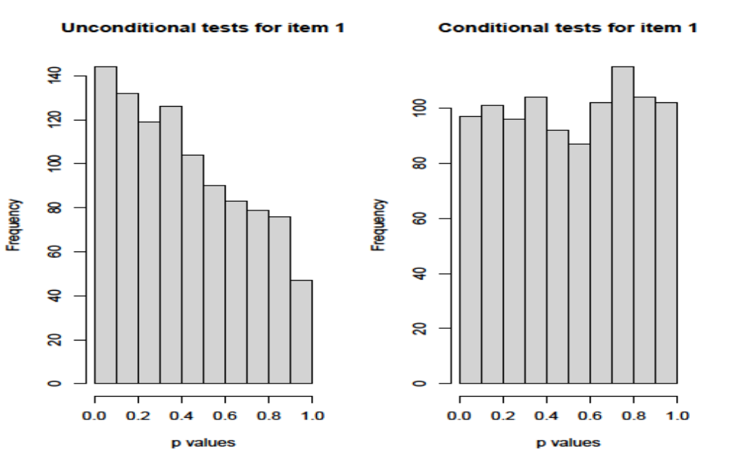
Figure 1b: Histograms of p values for the total chi-square test
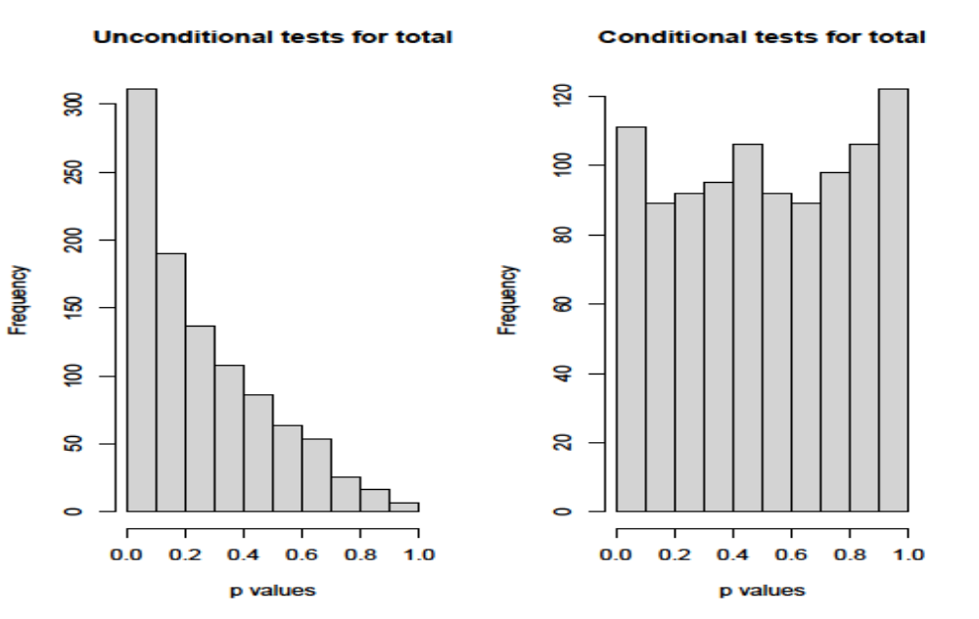

Figure 2 Chi-square and Bootstrap distributions
